# Game Concept

This will be a VR experience; in which the user will sit atop of a platform that move to different spots around a small map comprised of a colourful low-poly landscape. This will not be a thrilling game, it is just a nice easy paced overview game.

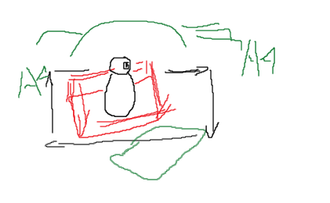

# Target Platform

Mobile VR – GearVR, Google Cardboard,

Desktop VR – Seated experience (use of the space key). Oculus Rift, HTC Vive (access to other OpenVR compatible headsets).

# Game Mechanics

* Player Movement on a platform
* Different locations – movement in linear fashion
* Single input method – Click or button on mobile VR, Spacebar on Desktop (or left click)

# Assets

* Model for the platform
* Model for the terrain.